Lab 01

# Objectives:

The purpose of the first lab of DBS211 is to familiarize yourself with the User Interface, SQL Developer, that we will be using throughout the course to communicate with the Oracle server. By the end of this lab you should be able to:

* Successfully establish a connection with and login to the Oracle database server using SQL Developer
* Run the sample database creation script
* Navigate SQL Developer to view the tables created, their structure and the data contained within them.

# Preface:

If you have not already done so, you will need to download the sample database creation script from blackboard and run it. These instructions are included in the W01 - Getting Started with SQL Developer document.

# LAB 01 - SUBMISSION

## Explore the Database

Answer the following questions in the SQL Developer Worksheet area and submit a Word document capturing the screenshots of the SQL results.

* Your Header of the Word file should include **FULL NAME, STUDENT ID and EMAIL**.
* The first screenshot of this lab should include the screenshot of your database login settings of your login information screen and the tables created.
* The following questions in your Word document should have the question, followed by the statement used or the answer in words and if it has a result in SQL Developer please paste the screenshot.
* EXAMPLE SCREENSHOT

1. How many tables have been created? List the names of the created tables.

**8 Tables are created with following names:-**

* **ORDERDETAILS**
* **PRODUCTLINES**
* **RETAILCUSTOMERS**
* **RETAILEMPLOYEES**
* **RETAILOFFICES**
* **RETAILORDERS**
* **RETAILPAYMENTS**
* **RETAILPRODUCTS**

1. Click on table **RETAILPRODUCTS**. Click on the Data tab near the top of the worksheet. How many rows are there in the table RETAILPRODUCTS?

**110 rows**

1. Can you try the following SQL statement and write down how many results were displayed. Was it different results for all 3?

3.1 SELECT * FROM RETAILPAYMENTS;

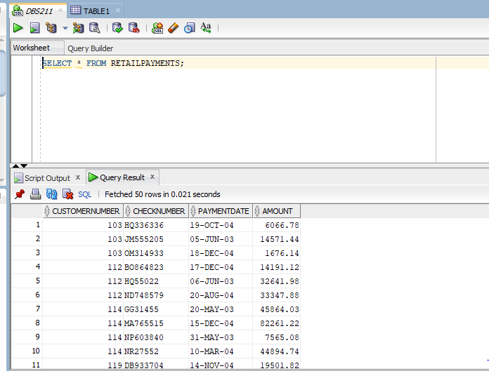

3.2 SELECT count(*) FROM RETAILPAYMENTS;

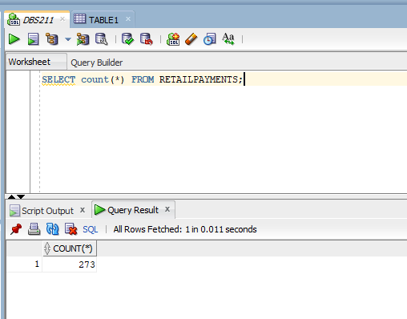

3.3 SELECT count(1) FROM RETAILPAYMENTS;

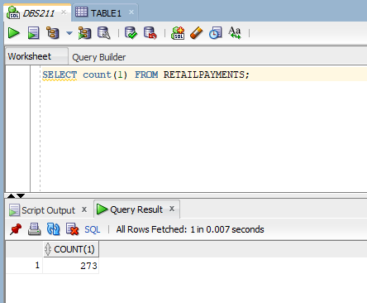

You will learn how to select rows and columns from a table by writing SQL select statements later in this course.

1. How many columns does the RETAILOFFICES table have? List the column names.

**There are 7 columns with following names:-**

* **OFFICECODE**
* **CITY**
* **PHONE**
* **ADDRESSLINE1**
* **ADDRESSLINE2**
* **STATE**
* **COUNTRY**
* **POSTALCODE**
* **TERRITORY**

1. What is the value of PRODUCTNAME and PRODUCTLINE for **PRODUCTCODE S18_1129** in RETAILPRODUCTS table.

**Product name:- 1993 Mazda RX-7**

**Product line:- Classic Cars**

1. Write the number of rows and columns for REATILORDERS and ORDERDETAILS tables in the following format.

Table Name Rows Columns

**___REATILORDERS**_______  **__326**___ **__7_____  
_____ORDERDETAILS_____ ____2996_ __5_____**

1. Right Click on the ORDERDETAILS table and choose tables/count rows. How many rows does the order details table include?

**2996 ROWS**

1. Write the following SQL statement in a new SQL worksheet.

desc RETAILORDERS;

You can also write

describe RETAILORDERS;

What is the result of the statement execution? Take a snap shot of the results and display them

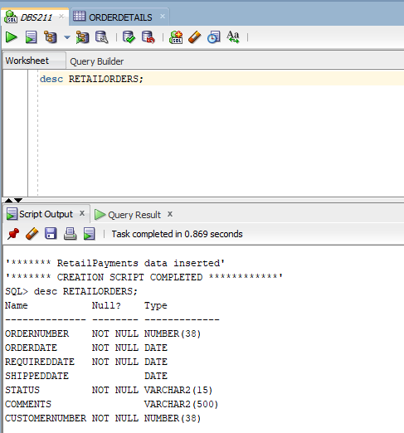

1. Type the following statements in, execute them, then briefly describe what the statement is doing!. Take a snap shot of the results and display them

SELECT * FROM RETAILCUSTOMERS ORDER BY CONTACTLASTNAME;

***This statement is selecting all files from “RETAILCUSTOMERS” table by contactlastname.***

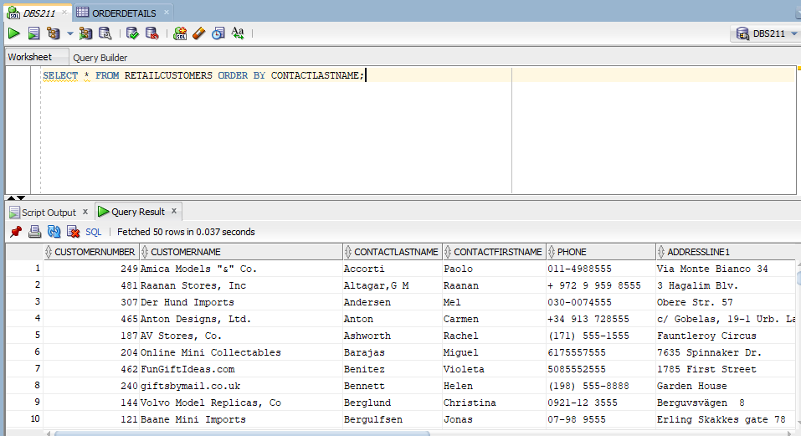

SELECT * FROM RETAILPAYMENTS ORDER BY PAYMENTDATE DESC;

***This statement is selecting all the files from RETAILPAYMENTS table by paymentdate desc.***

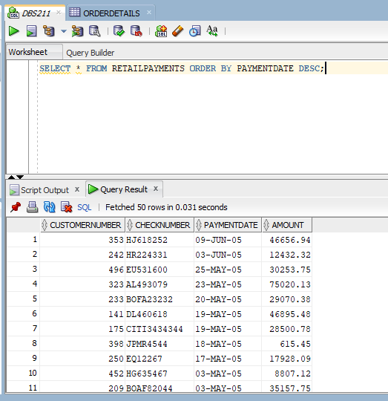

1. How many constraints does the RETAILPRODUCTS table have?

**11 Constriants**